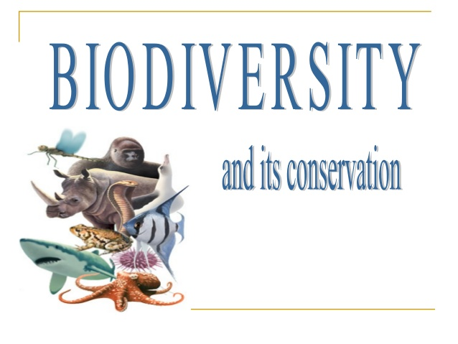

By : Dr Manju Sharma

BIODIVERSITY
A wide variety of living organisms including plants, animals and micro-organisms with whom we share this planet earth makes the world a beautiful place to live in. Living organisms exist almost everywhere from mountain peaks to the ocean depths; from deserts to the rainforests. They vary in their habit and behaviour, shapes, sizes and colour. The remarkable diversity of living organisms form an inseparable and significant parts of our planet however, the ever increasing human population is posing serious threats to bio-diversity.
In this lesson we shall learn about biodiversity and the ways humans are causing loss of biodiversity and the efforts that are being taken or need to be taken to protect and conserve the rich biodiversity.

- OBJECTIVES

- explain the concept of biodiversity and its role
- Types of biodiversity
- Uses of Biodiversity
- IUCN and Red List
- Loss and its cause
- Way forward to protect and conserve: In Situ & Ex Situ
- Related laws

- WHAT IS BIOLOGICAL DIVERSITY
- Biodiversity can be defined as a community of all the living organisms on the earth and the diversity among them from all the ecosystems. Biodiversity is thus the variability between the species, within the species and between the ecosystem.
- The term biodiversity was coined by Walter G. Rosen in the year 1986.
- Biodiversity holds ecological and economic significance. It provides us with nourishment, housing, fuel, clothing and several other resources. It also extracts monetary benefits through tourism. Therefore, it is very important to have a good knowledge of biodiversity for a sustainable livelihood
- Biodiversity plays a major role in maintaining the ecological balance of the ecosystem. It refers to the number of different species belonging to a particular region. In biodiversity, each individual species has a major role to play in the ecosystem.
- Ecological Role of Biodiversity:- Apart from providing ecological balance to the environment, each individual species of biodiversity has a major function to play in the ecosystem. They play a major role in the production and decomposition of organic wastes, fixing atmospheric gases and regulation of water and nutrients throughout the ecosystem. The stability of the ecosystem increases with the diversity of the species.
- Economical Role of Biodiversity :-Biodiversity acts as a source of energy and has a major role in providing raw materials for industrial products such as oils, lubricants, perfumes, dyes, paper, waxes, rubber, etc. Importance of plant species for various medicinal use has been known since ages. According to reports, more than 70 % of the anti-cancer drugs are derived from plants in the tropical rainforests.
- Scientific Role of Biodiversity :-Each species of the ecosystem contributes to providing enough evidence as to how life evolved on this planet and the role of each species in maintaining the sustainability of the ecosystem.

Types of Biodiversity
Biodiversity can be categorised into three main types:
- Genetic Diversity (Diversity within species)
- Species Diversity (Diversity between species)
- Ecosystem Diversity (Diversity between ecosystem)
1.Genetic Diversity
Every individual of a particular species differs from each other in its genetic makeup. This genetic variability among the members of any plant or animal species is known as genetic diversity. When two individuals are closely related, they share more genetic information among each other and hence, are more similar.
Each species, varying from bacteria to higher plants and animals, stores an immense amount of genetic information. For example, the number of genes is about 450-700 in mycoplasma, 4000 in bacteria (eg. Escherichia coli) , 13,000 in Fruit-fly (Drosophila melanogaster); 32,000 – 50,000 in rice (Oryza sativa); and 35,000 to 45,000 in human beings (Homo sapiens sapiens). This variation of genes, not only of numbers but of structure also, is of great value as it enables a population to adapt to its environment and to respond to the process of natural selection. If a species has more genetic variation, it can adapt better to the changed environmental conditions. Lower diversity in a species leads to genetic uniformity of genetically similar crop plants. This homogeneity is desirable in producing uniform quality of grain. But genetic uniformity restricts adaptability of a species to environmental stress as all the plants have same level of resistance.
For instance:- two brothers differ in their structure, although their parents are the same. The differences could be in alleles (different variants of the same gene), in entire gene (the traits determining particular characteristics) or in chromosomal structure.

2.Species Diversity
Species diversity can be defined as the variety of species within a particular region or habitat. This type of diversity can be found in both the natural ecosystem and agricultural ecosystem.
There are more than 85,000 flowering plant species in tropical North and South America, tropical and subtropical Asia has more than 50,000 flowering plants whereas, there are only 35,000 flowering plant species in tropical and subtropical Africa. But, Europe has around 11,300 vascular plants. Also, other areas, such as salt flats or a polluted stream, have fewer species.
Kinds of species that are present in an area is also important. When taxonomically unrelated species are present in an area, the area represents greater species diversity as compared to an area represented by taxonomically related species

3.Ecosystem Diversity
There are a large diversity of different ecosystems which have their own distinctive species. This ecosystem varies with each other as per their habitats and the difference in their species. This ecosystem diversity can be found within a specific geographical region or within a country or a state. This type of diversity also includes forests, grasslands, deserts and mountains.
For instance, the tropical south India with rich species diversity will have altogether different structure compared to the desert ecosystem which has far less number of plant and animal species. Likewise, the marine ecosystem although has many types of fishes, yet it differs from the freshwater ecosystem of rivers and lakes in terms of its characteristics. So such variations at ecosystem level are termed as ecosystem diversity.

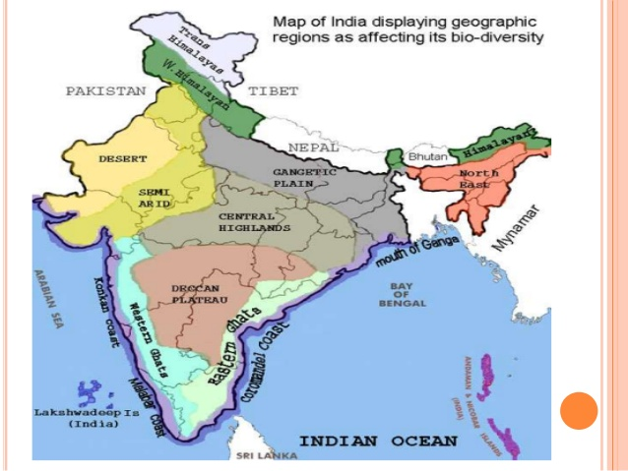
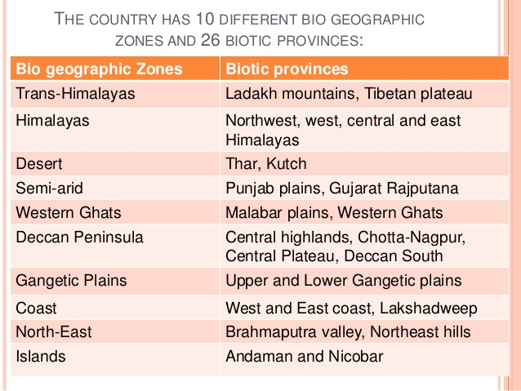

- WHY IS BIOLOGICAL DIVERSITY IMPORTANT ?

- Ecological values;
Firstly, it is important because it represents the almost infinite variety of plant and animal life, and the variety of the types of Earth’s ecosystems that support life as we know it. It enables humans to survive in what would otherwise result in adverse conditions. Biodiversity is the very stuff that supports the evolution and differentiation among the varying species. It’s why cats are cats and horses are horses and humans are humans. And, further, it is responsible for the differences among groups within the larger species. Look at how many seemingly different types of humans there are or jungle cats or birds. Water, wind, and sunlight generate much of the energy we use, and the action of the planet
- Cultural values:
Plants and animals are important part of the cultural life of humans. Human cultures have co-evolved with their environment and biological diversity can be impart a distinct cultural identity to different communities. The natural environment serves the inspirational, aesthetic, spiritual and educational needs of the people, of all cultures. In a majority of Indian villages and towns, plants like Tulsi (Ocimum sanctum), Peepal (Ficus religiosa), Khejri (Prosopis cineraria) are planted and considered sacred and worshipped.

- Recreational value;
Forests, wildlife, national parks and sanctuaries, garden and aquaria have high entertainment and recreation value. Ecotourism, photography, painting, film making and literary activities are closely related.

- Economic value;
Food, fibre, medicines, fuel wood and ornamental plants: Five thousand plant species are known to have been used as food by humans. Presently about 20 species feed the majority of the world’s population and just 3 or 4 only are the major staple crops to majority of population in the world. A large number of plants and animals materials are used for the treatment of various ailments. The usage of medicinal plants in India has an ancient history, dating back to the pre-vedic culture, at least 4000 years B. C. The therapeutic values of herbal medicines led to evolution of Ayurveda which means “science of life”. It is estimated that at least 70 % of the country’s population rely on herbal medicines and over 7000 species of plants are used for medicinal purposes. Wood is a basic commodity used worldwide for making furniture and for building purposes. Fire wood is the primary source of fuel widely used in third world countries. Wood and bamboo are used for making paper. Plants are the traditional source of fibre such as coir, hemp, flax, cotton, jute.

- Scientific Value;
Breeding material for crop improvement: Wild relatives of cultivated crop plants contain valuable genes that are of immense genetic value in crop improvement programmes. Genetic material or genes of wild crop plants are used to develop new varieties of cultivated crop plants for restructuring of the existing ones for improving yield or resistance of crops plants. For example: rice grown in Asia is protected from four main diseases by genes contributed by a single wild rice variety.
Research, Education and Monitoring There is still much to learn on how to get better use from biological resources, how to maintain the genetic base of harvested biological resources, and how to rehabilitate degraded ecosystems. Natural areas provide excellent living laboratories for such studies, for comparison with other areas under systems of use and for valuable research in ecology

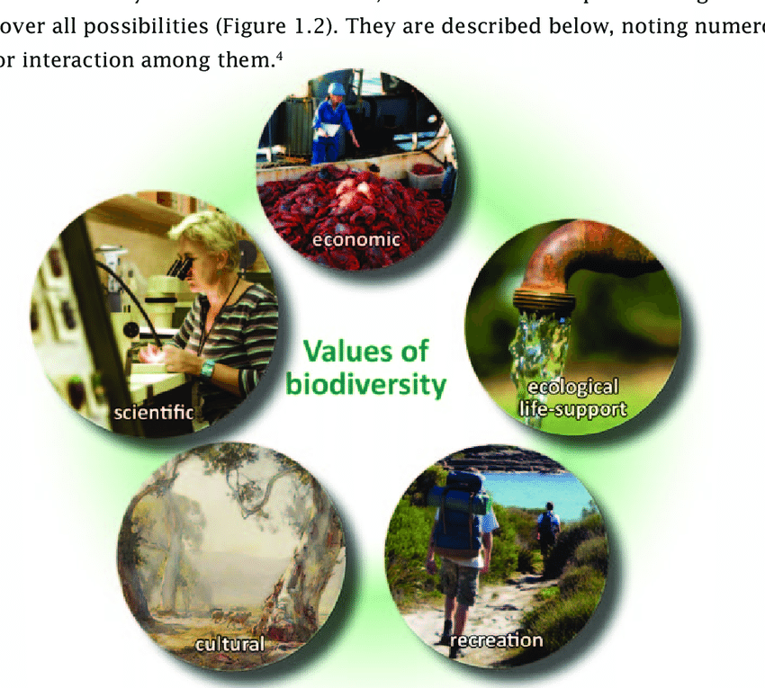

- IUCN
The World Conservation Union (IUCN) (formerly known as International Union for the Conservation of Nature and Natural Resources, IUCN) has recognized eight Red List categories according to the conservation status of species.

Objectives of IUCN
The International Union for Conservation of Nature works to achieve the following goals:
- To provide scientific data on the status of species and subspecies at a global level.
- To address the factors of concern and spread awareness regarding the species and biodiversity extinction.
- To plan a layout for the conservation of biodiversity.
IUCN Red List Users
The IUCN Red List provides accurate data on the status of different species on the Earth. This information is used by various departments, institutes, and organizations.
The users of the IUCN Red List are given below:
- Government agencies (National & International)
- Wildlife organizations and departments
- Conservation-related NGOs
- Natural resource planners
- Educational organizations
- Zoos and aquariums
- Media
- Business communities
Purpose of the IUCN Red List Data
The information cited in the IUCN Red List is used by various organizations in the following ways:
- International Agreements such as CITES, Ramsar Convention use the Red List data to make important decisions in sync with the status of nature as and when required.
- World Bank Group performance standard uses the IUCN Red List data to evaluate the risk of damage to biodiversity due to large-scale infrastructures and global projects.
- Zoos and National parks use this information to upgrade important policies like parks regulations from time to time.
Following are the 9 categories in the IUCN red list:

List Category | Definition
Extinct | A taxon is extinct when there is no reasonable doubt that the last individual has died
Extinct in the wild | A taxon is extinct in the wild when exhaustive surveys in known and/or expected habitats have failed to record an individual.
Critically endangered | A taxon is critically endangered when it is facing high risk of extinction in the wild in immediate future
Endangered | A taxon is endangered when it is not critically endangered but is facing a very high risk of extinction in the wild in near future.
Vulnerable | A taxon is vulnerable when it is not critically endangered or endangered but is facing high risk of extinction in the wild in the medium term future.
Near threatened | A taxon is near thrteatened when it is Likely to become endangered in the near future.
Lower risk | A taxon is lower risk when it has been evaluated and does not satisfy the criteria for critically endangered, endangered or vulnerable.
Data deficient | A taxon is data deficient when there is inadequate information to make any direct or indirect assessment of its risk of extinction
Not evaluated | A taxon is not evaluated when it has not yet been assessed against the above criteria.

- CAUSES FOR LOSS OF BIODIVERSITY
The accelerated rates of species extinctions that the world is facing now are largely due to human activities. There are four major causes
- Habitat loss and fragmentation
- Over-exploitation
- Alien species invasions
- Co-extinctions

- Habitat loss and fragmentation
Habitat loss and fragmentation is the most important cause of driving animals and plants to extinction. Habitat (natural home) destruction may result from clearing and burning forests, draining and filling of wetlands, converting natural areas for agricultural or industrial purpose.
The most intense examples of habitat loss come from tropical rain forests.
The Amazon rain forests protecting probably millions of species is being cut and cleared for agricultural purposes or for conversion to grasslands for raising beef cattle.
In addition to the total loss, the degradation of several habitats by pollution also threatens the existence of many species.
When large habitats are broken up into small fragments due to anthropogenic activities, mammals and birds necessitating large territories and certain animals with migratory habits are severely affected, leading to population regressions.
- Over Exploitation
Humans have always depended on nature for food and shelter, etc.The population explosion is the major reason for the over-exploitation of available resources. Many species extinctions in the last 500 years such as Steller’s sea cow, passenger pigeon were due to overexploitation by humans. Currently, several marine fish populations around the world are over-harvested, threatening the sustained existence of certain commercially important species
- Alien Species Invasion
When alien species are introduced by chance or deliberately, some of them turn aggressive and cause the extinction of local species.
Seeds catch on people’s clothes. Mice, rats and birds hitch-hike on ships. When such species land in new places, they breed extra fast due to absence of any enemy and often wipe out the native species already present there. Exotic species (new species entering geographical region) may wipe out the native ones.
A few examples are-
- Parthenium hysterophorus (Congress grass- a tropical American weed) has invaded many of the vacant areas in cities, towns and villages in India leading to removal of the local plants and the dependent animals.
- Nile perch, an exotic predatory fish introduced into Lake Victoria (South Africa) threatened the entire ecosystem of the lake by eliminating several native species of the small Cichlid fish that were endemic to this freshwater aquatic system.
- Water hyacinth clogs lakes and riversides and threatens the survival of many aquatic species. This is common in Indian plains.
- Lantana camara (an American weed) has invaded many forest lands in various parts of India and wiped out the native grass species.

- Co Extinction
When a species becomes extinct, the flora and fauna related to it in an essential way also become extinct.When a host fish species becomes extinct, its unique assemblage of parasites also meets the same destiny.
- CONSERVATION STRATEGIES
Conservation efforts can be grouped into the following two categories:
1.In-Situ Conservation- Conservation of a species is best done by protecting its habitat along with all the other species that live in it in nature. This is known as in-situ conservation, which is conserving a species in its own environment by creating National Parks and Wildlife Sanctuaries. i.e. Conservation of wild life in their natural place itself. e.g. Wildlife sanctuary, National Park, Biosphere reserve.
a) National park and wildlife sactuaries
India is unique in the richness and diversity of its vegetation and wildlife. India’s national parks and wildlife sanctuaries (including bird sanctuaries) are situated Ladakh in Himalayas to Southern tip of Tamil Nadu with its rich bio-diversity and heritage. Wildlife sanctuaries in India attract people from all over the world as the rarest of rare species are found here. With 96 national parks and over 500 wildlife sanctuaries, the range and diversity of India’s wildlife heritage is unique. Some of the main sanctuaries in India are: The Jim Corbett Tiger Reserve- Uttaranchal, Kanha National Park, Madhya Pradesh, Bandhavgarh National Park- Madhya Pradesh, Ranthambhor National Park-Sawai madhopur
b) Biosphere Reserves
These are representative parts of natural and cultural landscapes extending over large areas of terrestrial or coastal/marine ecosystems which are internationally recognized within UNESCO’s Man and the Biosphere Programme Thirteen biodiversity- rich representative ecosystems , largely within the forest land ( total area – 53,000 sq. km. ), have been designated as Biosphere Reserves in India.
The concept of Biosphere Reserves (BR) was launched in 1975 as a part of UNESCO’s Man and Biosphere Programme, dealing with the conservation of ecosystems and the genetic material they contain. A Biosphere Reserve consists of core, buffer and transition zones.
(a) The core zone is fully protected and natural area of the Biosphere Reserve least disturbed by human activities. It is legally protected ecosystem in which entry is not allowed except with permission for some special purpose. Destructive sampling for scientific investigations is prohibited.
(b) The buffer zone surrounds the core zone and is managed to accommodate a greater variety of resource use strategies, and research and educational activities.
(c) the transition zone, the outermost part of the Biosphere Reserve, is an area of active cooperation between the reserve management and the local people, wherein activities like settlements, cropping, forestry , recreation and other economic that are in harmony with the conservation goals. Till date there were 553 biosphere reserves located
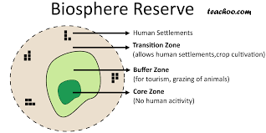
Biosphere Reserves examples:-
1. The Great Run of Kutch 2. Simlipal (Orissa) 3. The Gulf of Mannar 4. Amarkantak 5. Sunder bans 6. Manas (Assam) 7. Cold Desert in Ladakh 8. Kanchenjunga (Sikkim) 9. The Nanda Devi 10. Agastya Mala (Trivandrum) 11. The Nilgiris (Oldest Reserve) 12. Great Nicobar 13. Dehang Debang 14. Nokrek 15. Pachmarhi 16. Dibru Saikhowa 17. Seshachalam 18. Panna
2. Ex-Situ Conservation – When there are situations in which an endangered species is so close to extinction that unless alternate methods are instituted, the species may be rapidly driven to extinction. This strategy is known as ex-situ conservation, i.e. outside its natural habitat in a carefully controlled situation such as a botanical garden for plants or a zoological park for animals, where there is expertise to multiply the species under artificially managed conditions. These breeding programs for rare plants and animals are however more expensive than managing a Protected Area. There is also another form of preserving a plant by preserving its germplasm in a gene bank so that it can be used if needed in future.
a) Botanical gardens, zoos, etc. To complement in-situ conservation efforts, ex-situ conservation is being undertaken through setting up botanic gardens, zoos, medicinal plant parks, etc by various agencies. The Indian Botanical Garden in Howrah (West Bengal) is over 200 years old. Other important botanical gardens are in Ooty, Bangalore and Lucknow. The most recent one is The Botanical Garden of Indian Republic established at NOIDA, near Delhi in April, 2002. The main objectives of this garden are – • ex-situ conservation and propagation of important threatened plant species, • serve as a Centre of Excellence for conservation., research and training, • build public awareness through education on plant diversity and need for conservation.
A number of zoos have been developed in the country. These zoological parks have been looked upon essentially as centres of education about animal species and recreation. They have also played an important role in the conservation of endangered animal species such as the Manipur Thamin Deer (Cerus eldi eldi) and the White winged Wood Duck (Cairina scutulata). Notable successful examples of captive breeding are those of Gangetic gharial (Gavialis gangeticus), turtles and the white tiger.
b) Gene Banks : Ex-situ collection and preservation of genetic resources is done through gene banks and seed banks. The National Bureau of Plant Genetic Resources (NBPGR), New Delhi preserves seeds of wild relatives of crop plants as well as cultivated varieties; the National Bureau of Animal Genetic Resources at Karnal, Haryana maintains the genetic material for domesticated animals, and the National Bureau of Fish Genetic Resources, Lucknow for fishes.
c) Cryopreservation: (“freeze preservation”) is particularly useful for conserving vegetative propagated crops. Cryopreservation is the storage of material at ultra low temperature of liquid nitrogen (-1960C) and essentially involves suspension of all metabolic processes and activities. Cryopreservation has been successfully applied to meristems, zygotic and somatic embryos, pollen, protoplasts cells and suspension cultures of a number of plant species.
d) Conservation at molecular level (DNA level): In addition to above, germplasm conservation at molecular level is now feasible and attracting attention. Cloned DNA and material having DNA in its native state can all be used for genetic conservation. Furthermore, non-viable material representing valuable genotypes stored in gene banks can all be used as sources of DNA libraries from where a relevant gene or a combination of genes can be recovered.
Legal measures : Market demand for some body parts like bones of tiger, rhino horns, furs, ivory, skins, musk, peacock feathers , etc results in killing the wild animals. The Wildlife Protection Act (1972) contain provisions for penalties or punishment to prevent poaching and illegal trade. India is also a signatory to the Convention on International Trade in Endangered Species of Wild Fauna and Flora (CITES). The Convention entered into force on 1st July, 1975. In addition to this, India is also a signatory to Convention on Biological Diversity (CBD), which it signed on 29th December, 1993 at Rio de Janeiro during the Earth Summit. The Convention hasthree key objectives:
  - Conservation of biological diversity,
  - 2 Sustainable use of biodiversity and
  - 3. Fair and equitable sharing of benefits arising out of the utilization of genetic resources. The CITES and the CBD are international initiatives. Government of India have also passed the Biological Diversity Act, 2002,
Biological Diversity Act, 2002
• This Act provides for setting up of a National Biodiversity Authority (NBA), State Biodiversity Boards (SBB) and Biodiversity Management Committees (BMC) in local bodies.
• All foreign nationals organizations require prior approval of NBA for obtaining biological resources and/or associated knowledge for any use.
• Similarly, Indian nationals or organizations will require to give prior intimation to the concerned SBB about any biological resources being imported for commercial use. The SBB may prohibit the import if found to violate the objectives of conservation, sustainable use and benefit sharing.
• However, local people and communities of the area, including Vaids and Hakims will have free access to use biological resources within the country for their own use, medicinal purposes and research.
• While granting approvals, NBA will impose terms and conditions to secure equitable sharing of benefits.
• There is a enabling provision for setting up a framework for protecting traditional knowledge
• The monetary benefits, fees and royalties, as a result of approvals by NBA are to be deposited in National Biodiversity Fund which will be used for conservation and development of areas from where the resource has been accessed, in consultation with local self government.
• World Wide Fund for Nature (WWF) and World Conservation Union supports projects to promote conservation and appropriate development of Biosphere Reserves.

REFERENCES
- Linkdin
- Wikipaedia
- NIOS Open module https://www.nios.ac.in/media/documents/333courseE/15.pdf
- Textbook of Environmental studies for Ug students by Erach Bharucha
- https://byjus.com/free-ias-prep/environment-notes-upsc/

